
MM570 Applied Statistics for Psychology
Unit 9 Project: Descriptive Statistics
This is a course level assessment assignment. MM570-3: Interpret correctly the output from SPSS analyses/statistical tests.
Your Name:

HINTS AND HELP
Dataset: Stat_Grades.sav can be found in Doc Sharing under the Instructor Graded Projects category.

Note: When asked to include the interpretation of the results and final conclusions, be sure to include all results, an interpretation of the meaning of the results, and final conclusions that a common person can understand. Make sure you use complete sentences, paragraph form (single spacing), proper grammar, and correct spelling. Minimal or incomplete responses can lose points. Include any SPSS results that you use, but do not include SPSS results that are not part of your solution.

Hint: You are asked to determine “appropriate” tests and methods, and to make calculations. This means that you will have to determine which tests or methods are best and why.

Remember to always show all of your work and each of your steps.
For each question, follow the appropriate steps.
1) Write the hypothesis - Construct the null(s) and alternative(s) clearly and appropriately.
3) Run the appropriate SPSS test(s) and include the appropriate results
4) Explain and evaluate the SPSS results
5) Write a complete and paragraph form conclusion that can be understood by a normal non-statistical person.

Use the Live Binder for further assistance. There is a link to the Live Binder under every Unit.

Point Possible | Grading Criteria
A: 153 - 170 points | Student work demonstrates mastery of the objectives assessed by the Assignment. This is evidenced by at least the following:  · The selection of the statistical procedure(s) is/are the most appropriate ones for answering the questions; specifically, the correct ANOVA test method is selected for each question.  · The statistical procedure was calculated correctly using SPSS.  · The interpretation of the SPSS output is correct and complete, including applying the (Sig. in SPSS) p-value to determine null hypothesis rejection.  · The results of the statistical analyses are presented in easy to understand, non-statistical language that addresses the research question.  · SPSS output that is not needed in the solution is not included. Only appropriate SPSS output are included.  · Each step of the hypothesis testing procedure is included and Ho and Ha are clearly written.  · All aspects of the tests are included and explained, including the Post Hoc results and the interaction plot.  · Appropriate regression prediction equations are created and evaluated.

Use alpha = .05 for this project.

1. Compare the different Ethnicities of students in the Stat_Grades.sav dataset to determine if there is a statistically significant difference in the average Final Exam Points between the different ethnic groups. Be sure to state the hypothesis, state Ho and Ha, include and explain all SPSS results, and write final conclusions for the full results of the test. Include Post Hoc results and the plot. Be sure that your final conclusions are written in common terms for an average person to understand.
(a) What is the hypothesis being tested?
Solution
We are testing if there is significant difference in average final exam points between different ethnic groups.

(b) What are Ho and Ha?
Ho: the average final exam points are equal for all ethnicities.
Ha: the average final exam points are not equal for all ethnicities.
(c) What statistical test will you run - and include all the SPSS outputs (including the plot and post hoc)?
Solution

Descriptives
Final Exam Points
 | N | Mean | Std. Deviation | Std. Error | 95% Confidence Interval for Mean |  | Minimum | Maximum
 |  |  |  |  | Lower Bound | Upper Bound | Minimum | Maximum
AMERICAN INDIAN | 5 | 59.80 | 8.758 | 3.917 | 48.93 | 70.67 | 48 | 72
ASIAN | 20 | 62.85 | 7.177 | 1.605 | 59.49 | 66.21 | 50 | 75
AFRO-AMERICAN | 24 | 61.96 | 8.369 | 1.708 | 58.42 | 65.49 | 43 | 75
CAUCASIAN | 45 | 61.67 | 7.731 | 1.153 | 59.34 | 63.99 | 42 | 74
HISPANIC | 11 | 57.91 | 9.148 | 2.758 | 51.76 | 64.05 | 40 | 71
Total | 105 | 61.48 | 7.943 | .775 | 59.94 | 63.01 | 40 | 75

ANOVA
Final Exam Points
 | Sum of Squares | df | Mean Square | F | Sig.
Between Groups | 198.973 | 4 | 49.743 | .782 | .540
Within Groups | 6363.217 | 100 | 63.632
Total | 6562.190 | 104

Multiple Comparisons
Dependent Variable: Final Exam Points
Tukey HSD
(I) Ethnicity | (J) Ethnicity | Mean Difference (I-J) | Std. Error | Sig. | 95% Confidence Interval
 |  |  |  |  | Lower Bound | Upper Bound
AMERICAN INDIAN | ASIAN | -3.050 | 3.988 | .940 | -14.13 | 8.03
AMERICAN INDIAN | AFRO-AMERICAN | -2.158 | 3.921 | .982 | -13.05 | 8.74
AMERICAN INDIAN | CAUCASIAN | -1.867 | 3.760 | .988 | -12.31 | 8.58
AMERICAN INDIAN | HISPANIC | 1.891 | 4.302 | .992 | -10.06 | 13.84
ASIAN | AMERICAN INDIAN | 3.050 | 3.988 | .940 | -8.03 | 14.13
ASIAN | AFRO-AMERICAN | .892 | 2.415 | .996 | -5.82 | 7.60
ASIAN | CAUCASIAN | 1.183 | 2.144 | .981 | -4.77 | 7.14
ASIAN | HISPANIC | 4.941 | 2.994 | .469 | -3.38 | 13.26
AFRO-AMERICAN | AMERICAN INDIAN | 2.158 | 3.921 | .982 | -8.74 | 13.05
AFRO-AMERICAN | ASIAN | -.892 | 2.415 | .996 | -7.60 | 5.82
AFRO-AMERICAN | CAUCASIAN | .292 | 2.016 | 1.000 | -5.31 | 5.89
AFRO-AMERICAN | HISPANIC | 4.049 | 2.904 | .633 | -4.02 | 12.12
CAUCASIAN | AMERICAN INDIAN | 1.867 | 3.760 | .988 | -8.58 | 12.31
CAUCASIAN | ASIAN | -1.183 | 2.144 | .981 | -7.14 | 4.77
CAUCASIAN | AFRO-AMERICAN | -.292 | 2.016 | 1.000 | -5.89 | 5.31
CAUCASIAN | HISPANIC | 3.758 | 2.683 | .629 | -3.70 | 11.21
HISPANIC | AMERICAN INDIAN | -1.891 | 4.302 | .992 | -13.84 | 10.06
HISPANIC | ASIAN | -4.941 | 2.994 | .469 | -13.26 | 3.38
HISPANIC | AFRO-AMERICAN | -4.049 | 2.904 | .633 | -12.12 | 4.02
HISPANIC | CAUCASIAN | -3.758 | 2.683 | .629 | -11.21 | 3.70

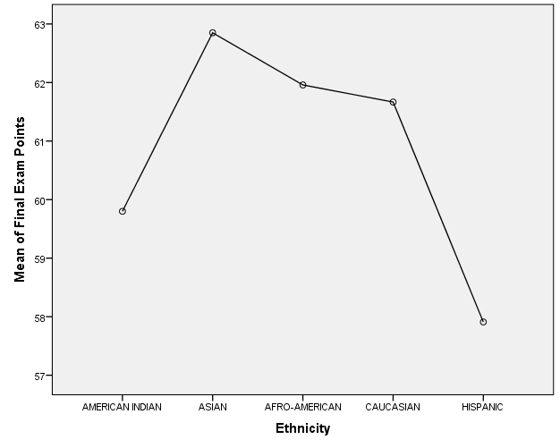

(d) Explain the full results for the statistical test that you ran above. Was a post hoc actually needed in this case? Why or why not? Does the Post Hoc confirm your results, explain? What does the plot tell you about the interaction, explain?
Solution
From the analysis post hock test is not required since ANOVA test results show there is no significant difference between the average for all groups. Post hock test affirms this because no interaction that is significant at 5% confidence level. The plot shows that the mean for all groups are not different. Hispanics have the lowest mean followed by American-India, Afro American and Asian.
(e) Write a full conclusion for all results on this test in a way that can be understood by a non-statistical person. This answer will be at least 100 words or more.

Solution
The ANOVA results show F(4, 104) = 0.782 and p = 0.540. This result implies that there was no statistically significant difference between the groups since p-value is greater than alpha (0.05). Therefore, we do not reject the null hypothesis. The results for post hock analysis confirm this since no interaction is less than 0.05 implying the differences are not significant. The descriptive statistics shows the total number of participants were 105 with 5 American Indian, 20 Asians, 24 Afro American, 45 Caucasian and 11 Hispanic. The least mean is 57.91 for Hispanic and the highest group was Asian with mean of 62.85.
2. Extend the hypothesis from number one above. Compare the different ethnicities of the students in the Stat_Grades.sav dataset and the genders to determine if there is a statistically significant difference in the average Final Exam Points between the different ethnicities and different genders. Be sure to state the hypothesis, state all Ho and Ha, include and explain all SPSS results, and write final conclusions for the full results of the test. Include Post Hoc results, note any interactions and whether they are significant, and include and explain the plot. Be sure that your final conclusions are written in common terms for an average person to understand.

- What is the hypothesis being tested?
We are testing if there is significance difference between the final grade by ethnicity and gender. In this case we are going to ANOVA test.
- What are the set of Ho’s and Ha’s?
Ho: there is no significance difference in final grade between ethnicity groups and gender.
Ha: there is significance difference in final grade between ethnicity groups and gender.

- What statistical test will you run - and include all the SPSS outputs (including the plot and post hoc)?
The statistical tests to be carried out are univariate ANOVA.

Descriptive Statistics
Dependent Variable: Final Exam Points
Gender | Ethnicity | Mean | Std. Deviation | N
FEMALE | AMERICAN INDIAN | 62.75 | 6.652 | 4
FEMALE | ASIAN | 64.92 | 7.320 | 13
FEMALE | AFRO-AMERICAN | 63.79 | 7.698 | 14
FEMALE | CAUCASIAN | 61.00 | 7.632 | 26
FEMALE | HISPANIC | 59.57 | 7.254 | 7
FEMALE | Total | 62.36 | 7.490 | 64
MALE | AMERICAN INDIAN | 48.00 | . | 1
MALE | ASIAN | 59.00 | 5.416 | 7
MALE | AFRO-AMERICAN | 59.40 | 8.996 | 10
MALE | CAUCASIAN | 62.58 | 7.981 | 19
MALE | HISPANIC | 55.00 | 12.490 | 4
MALE | Total | 60.10 | 8.514 | 41
Total | AMERICAN INDIAN | 59.80 | 8.758 | 5
Total | ASIAN | 62.85 | 7.177 | 20
Total | AFRO-AMERICAN | 61.96 | 8.369 | 24
Total | CAUCASIAN | 61.67 | 7.731 | 45
Total | HISPANIC | 57.91 | 9.148 | 11
Total | Total | 61.48 | 7.943 | 105

2. Gender
Dependent Variable: Final Exam Points
Gender | Mean | Std. Error | 95% Confidence Interval
Gender | Mean | Std. Error | Lower Bound | Upper Bound
FEMALE | 62.406 | 1.194 | 60.037 | 64.776
MALE | 56.796 | 1.949 | 52.927 | 60.665

Tests of Between-Subjects Effects
Dependent Variable: Final Exam Points
Source | Type III Sum of Squares | df | Mean Square | F | Sig.
Corrected Model | 725.414ª | 9 | 80.602 | 1.312 | .241
Intercept | 167153.102 | 1 | 167153.102 | 2720.602 | .000
gender | 370.266 | 1 | 370.266 | 6.026 | .016
ethnicit | 293.065 | 4 | 73.266 | 1.192 | .319
gender * ethnicit | 387.279 | 4 | 96.820 | 1.576 | .187
Error | 5836.776 | 95 | 61.440
Total | 403391.000 | 105
Corrected Total | 6562.190 | 104
a. R Squared = .111 (Adjusted R Squared = .026)

Multiple Comparisons
Dependent Variable: Final Exam Points
Tukey HSD
(I) Ethnicity | (J) Ethnicity | Mean Difference (I-J) | Std. Error | Sig. | 95% Confidence Interval
 |  |  |  |  | Lower Bound | Upper Bound
AMERICAN INDIAN | ASIAN | -3.05 | 3.919 | .936 | -13.95 | 7.85
AMERICAN INDIAN | AFRO-AMERICAN | -2.16 | 3.853 | .980 | -12.87 | 8.56
AMERICAN INDIAN | CAUCASIAN | -1.87 | 3.695 | .987 | -12.14 | 8.41
AMERICAN INDIAN | HISPANIC | 1.89 | 4.228 | .992 | -9.87 | 13.65
ASIAN | AMERICAN INDIAN | 3.05 | 3.919 | .936 | -7.85 | 13.95
ASIAN | AFRO-AMERICAN | .89 | 2.373 | .996 | -5.71 | 7.49
ASIAN | CAUCASIAN | 1.18 | 2.106 | .980 | -4.67 | 7.04
ASIAN | HISPANIC | 4.94 | 2.942 | .452 | -3.24 | 13.12
AFRO-AMERICAN | AMERICAN INDIAN | 2.16 | 3.853 | .980 | -8.56 | 12.87
AFRO-AMERICAN | ASIAN | -.89 | 2.373 | .996 | -7.49 | 5.71
AFRO-AMERICAN | CAUCASIAN | .29 | 1.981 | 1.000 | -5.22 | 5.80
AFRO-AMERICAN | HISPANIC | 4.05 | 2.854 | .617 | -3.89 | 11.99
CAUCASIAN | AMERICAN INDIAN | 1.87 | 3.695 | .987 | -8.41 | 12.14
CAUCASIAN | ASIAN | -1.18 | 2.106 | .980 | -7.04 | 4.67
CAUCASIAN | AFRO-AMERICAN | -.29 | 1.981 | 1.000 | -5.80 | 5.22
CAUCASIAN | HISPANIC | 3.76 | 2.636 | .613 | -3.57 | 11.09
HISPANIC | AMERICAN INDIAN | -1.89 | 4.228 | .992 | -13.65 | 9.87
HISPANIC | ASIAN | -4.94 | 2.942 | .452 | -13.12 | 3.24
HISPANIC | AFRO-AMERICAN | -4.05 | 2.854 | .617 | -11.99 | 3.89
HISPANIC | CAUCASIAN | -3.76 | 2.636 | .613 | -11.09 | 3.57
Based on observed means.
The error term is Mean Square(Error) = 61.440.

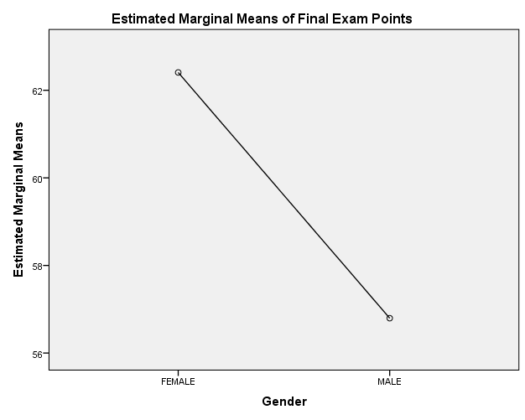

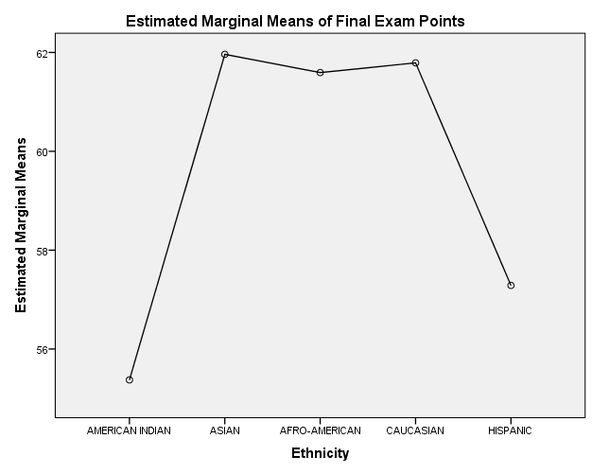
- Explain the full results of the statistical test you have run. Was a post hoc actually needed in this case? Why or why not? Does the Post Hoc confirm your test results, explain? What does the plot tell you about the interaction, explain?
Solution
The analysis run is univariate ANOVA. Post hoc test was required since the gender is significant. We would like to a certain which interaction groups in gender might be making the result significant. However, post hoc was not carried out by SPSS since gender has less than tree groups. The is no significance difference in final exam result by ethnic groups as implied by ANOVA test. This result is confirmed by post hoc since all p-values of the test are more than 5%. This implies that there is no significant difference between ethnic groups in final exam score.
- Write a full conclusion for all results on this test in a way that can be understood by a non-statistical person. This answer will be at least 100 words or more.
Solution
ANOVA test shows that p value of gender (0.016) is less than 0.05 we conclude that there is difference in final exam score by gender. Females have a mean of 62.046 and male have a mean of 56.796. The interaction between gender and ethnic groups is not significant since is p-value (0.817) is greater than alpha (0.05). This implies that for all groups, the score of male and females is not significantly different. There is also no significant difference in mean for the final exam score by ethnic groups. ANOVA result shows that its p-value is 0.319 which is greater than 0.05.
3. Prediction and Regression. If you recall from the Unit 3 Project, you looked at how to measure the relationship (correlation) between any two variables. You also learned that if two variables are strongly correlated (related) with each other, that one variable can be used to estimate or predict the other. The equation used to make this prediction is called a regression equation.

Use the following SPSS outputs to answer the questions. The two variables in this case are Final Exam Points and Total Points.

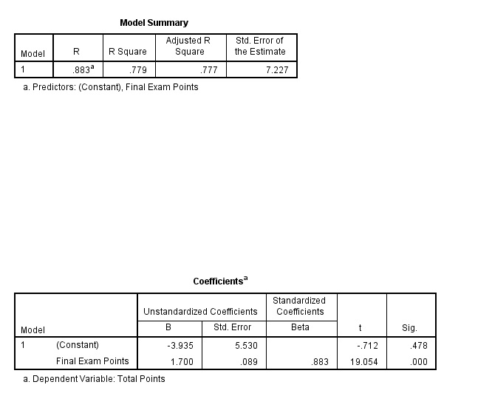
- What are the two variables that this question is investigating? Notice that the SPSS output above tells you that the r-value (called “R”) is .883. Is this r-value strong enough to allow you to perform prediction between these two variables? Explain.
Solution
The two variables in question are final exam points are total points. Final exam points is the independent variable while total points is dependent variable. The R-value is strong enough to warrant carrying out prediction of total points given final exam points. The R-value implies that there is 88.3% variation between in final exam points and total points.
- Using the “Coefficients” SPSS output above, create the prediction equation. Remember that your independent or “x” variable is Final Exam Points and your dependent or “y” variable is Total Points. Write the prediction equation here.
y = -3.935 + 1.700 x
where by y = Total points and x = Final exam points.

(c) Using the prediction equation that you created in part (b), predict the Total Points for a student with a Final Exam Points value of 61. Show all work.
Solution
Total points = -3.935 + 1.700 (61)
= 99.765

4. From the Stat_Grades.sav dataset, use Quiz 1 and Quiz 5 to answer these questions. The question you will be considering here as you answer the questions below is “Is the score on Quiz 1 highly correlated to the score on Quiz 5 and can one be used to estimate or predict the other?”

- What is the correlation or relationship (r-value) between Quiz 1 and Quiz 5? Is it weak, medium, or strong? Is it strong enough to use for prediction?
Solution

Correlations
 |  | Quiz 1 Points | Quiz 5 Points
Quiz 1 Points | Pearson Correlation | 1 | .504**
Quiz 1 Points | Sig. (2-tailed) |  | .000
Quiz 1 Points | N | 105 | 105
Quiz 5 Points | Pearson Correlation | .504** | 1
Quiz 5 Points | Sig. (2-tailed) | .000
Quiz 5 Points | N | 105 | 105
**. Correlation is significant at the 0.01 level (2-tailed).
The correlation between the two variables is 0.504 which implies that there is mediumly strong positive relationship between quiz 1 and 2.

- Use SPSS and run a regression analysis on Quiz 1 and Quiz 5. Place the SPSS “Coefficients” output (only) here.
Solution

Coefficientsª
Model |  | Unstandardized Coefficients |  | Standardized Coefficients | t | Sig.
 |  | B | Std. Error | Beta | t | Sig.
1 | (Constant) | 5.189 | .476 |  | 10.896 | .000
1 | Quiz 1 Points | .359 | .061 | .504 | 5.921 | .000
a. Dependent Variable: Quiz 5 Points

- Use the SPSS output to create the regression (prediction) equation. Remember, you are trying to predict how a student will perform on Quiz 5 based on how they do on Quiz 1. What is your dependent (y) variable? What is your independent (x) variable? Write the prediction equation here.
Solution
Dependent variable is quiz 5 and independent variable is quiz 1. The prediction equation is: -
y = 5.189 + 0.359 (x)
where by y = quiz 5 and x = quiz 1.
- Use your prediction equation to predict how a student would perform on Quiz 5 if they got a 7 on Quiz 1. Show all work.
Solution
Quiz 5 = 5.189 + 0.359 (7)
= 7.702

Submitting your Project

Make sure your name is on your project and saved to your computer. When you are ready to submit your completed project, click on the Dropbox and complete the steps below:

• Click the link that says “Submit an Assignment.”
• In the “Submit to Basket” menu, select Unit 9: Project.
• In the “Comments” field, include your name and Unit 9 Project.
• Click the “Add Attachments” button.
• Follow the steps listed to attach your Word document.
• You should revisit the Dropbox to view any helpful feedback your instructor has left for you.
• Make sure that you save a copy of your submitted and returned assignment.

